Project Tutorial: Building a Multi-OS Virtual Lab
Introduction
In the modern cybersecurity landscape, Security Operations Center (SOC) analysts must have hands-on experience with multiple operating systems. Corporate environments commonly deploy both Windows and Linux servers, each generating distinct logs, alerts, and vulnerabilities. This project focuses on building a safe and controlled virtual lab environment to simulate real-world scenarios. The purpose is to understand system behavior, test security tools, and strengthen analysis skills across diverse OS platforms.
Project Goal
The objective is to create a virtual environment consisting of two virtual machines (VMs): one running Windows 11 (representing a corporate workstation) and the other running Debian Linux (representing a Linux server). This lab setup will be connected through carefully selected network configurations to simulate realistic enterprise conditions.

Part 1: Understanding VMware Networking
Before deploying the virtual machines, it is essential to understand the networking modes available in VMware. The correct choice ensures both functionality and safety.
1. NAT (Network Address Translation)
- What it does: Shares your host computer’s IP address. The VM can access the internet but remains invisible to other devices on the local network.
- Example: You want to browse the web or download tools inside your VM without exposing it to other devices in your home or office. Perfect for safe internet use during practice.
2. Bridged Adapter
- What it does: Connects the VM directly to your physical network. The VM receives its own IP address from your router, just like another real device.
- Example: You want to run a web server on your Linux VM and test it from your phone or another PC on the same Wi-Fi. Since the VM has its own IP, any device can connect to it.
3. Host-Only Adapter
- What it does: Creates a private network between your host machine and your VMs. The VM cannot access the internet.
- Example: You’re practicing file transfers, ping tests, or software setup between your host and VM without needing internet. It’s safe and isolated—ideal for basic networking practice.
4. Internal Network
- What it does: A completely closed network where VMs can talk only to each other. No internet and no host access.
- Example: You’re testing malware or attack simulations between two VMs (like a Kali Linux attacker and a Windows victim). This ensures the malware cannot escape into your real network.
5. NAT Network
- What it does: Similar to NAT but allows multiple VMs to communicate with each other while sharing the host’s internet connection.
- Example: You’re building a mini corporate lab with a Windows workstation VM and a Linux server VM. They can both access the internet and also talk to each other for client-server testing.
Part 2: Creating VM #1 – Windows 11 (Corporate Workstation)
Step 1: Download VMware Workstation (or Fusion)
On November 11, 2024, VMware announced that its desktop hypervisor products—VMware Workstation (for Windows/Linux) and VMware Fusion (for macOS)—would be made completely free for all users. The link is give below the screenshot.
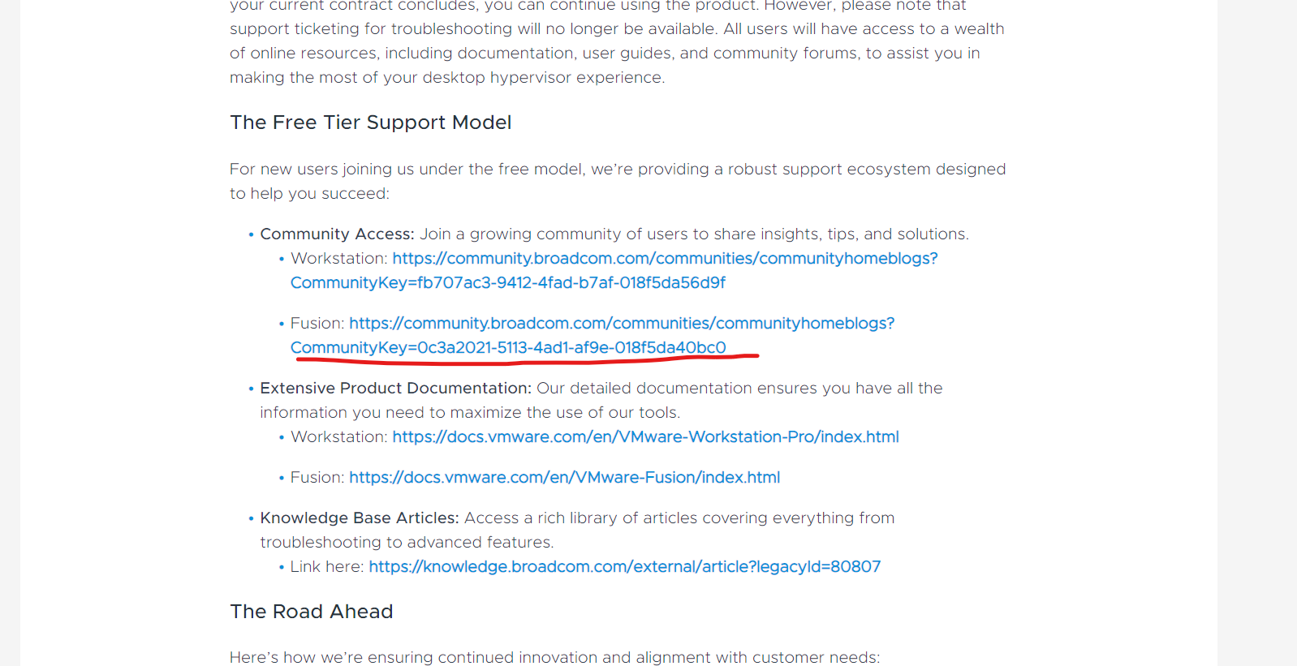
https://blogs.vmware.com/cloud-foundation/2024/11/11/vmware-fusion-and-workstation-are-now-free-for-all-users/
Step 1.2: Find the How to Download VMware Fusion and Click on the given link.
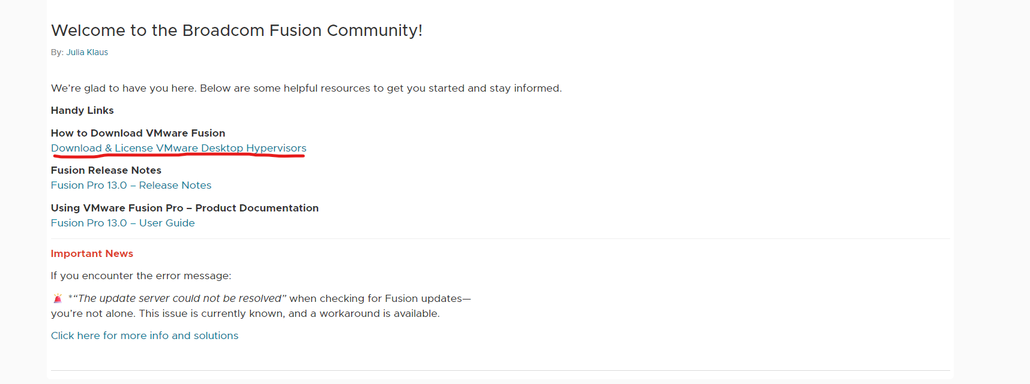
Step 1.3: If you are using macOS, you can proceed by downloading VMware Fusion, which is designed specifically for Apple systems. However, since my system runs on Windows, I selected VMware Workstation Pro as the preferred virtualization platform.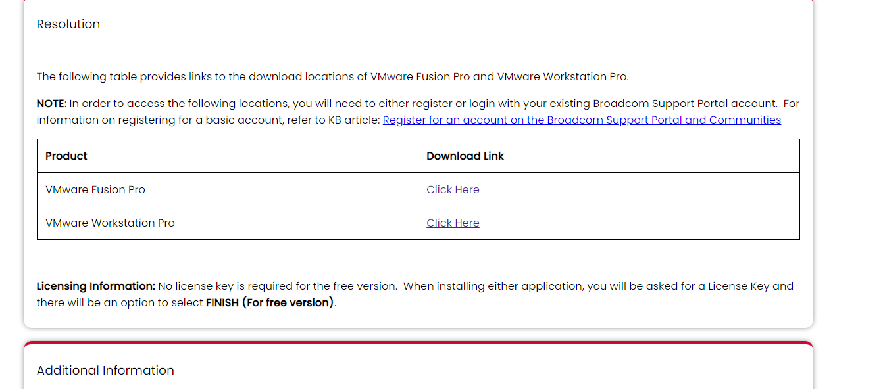
Step 1.4: Since I am using a Windows-based system, I selected VMware Workstation Pro for Windows from the available download options. VMware also provides a dedicated version for Linux users, ensuring cross-platform support.

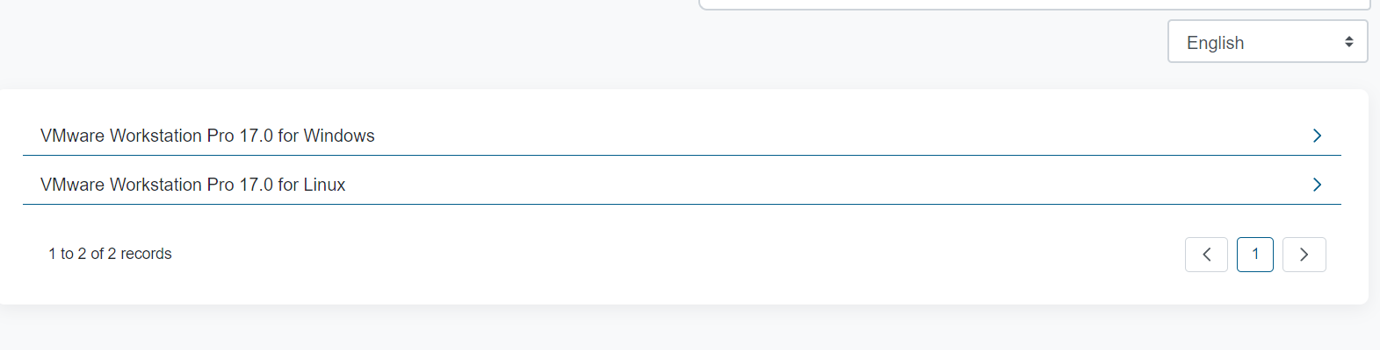
Step 1.5: Before downloading, VMware requires users to accept the End User License Agreement (EULA). Initially, the checkbox to agree to the Terms and Conditions appeared greyed out. To enable it, I clicked the Terms and Conditions link, which opened in a new window. Once I reviewed the document, the checkbox became active, allowing me to proceed with the download of VMware Workstation Pro.
This step is important because it ensures that users acknowledge VMware’s licensing terms before installation—maintaining compliance and legal use of the software.

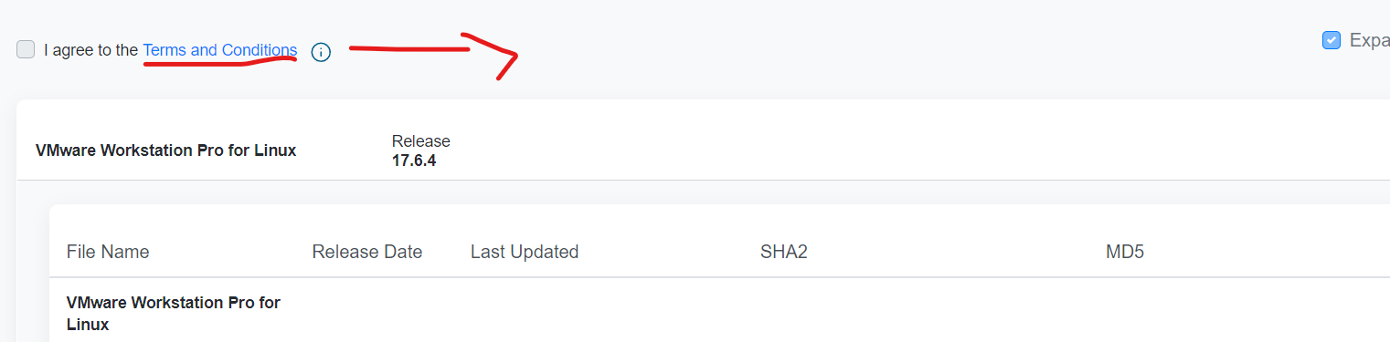
Step 1.6: After the download was complete, I proceeded with the installation process. VMware provides a straightforward installation wizard that guides the user step by step. I simply launched the installer, accepted the default settings, and completed the setup. Once finished, VMware Workstation Pro was successfully installed and ready to use.
This step is important because the installation wizard ensures all necessary components (such as drivers and services) are correctly configured, allowing the virtual environment to run smoothly without manual intervention.
Step 2: Downloading Windows 11 ISO and Running it on VMware.
Step 2.1: I accessed the link, downloaded the Windows 11 ISO (x64) file from Microsoft, and waited for the disc image to complete downloading.
Link: https://www.microsoft.com/en-us/evalcenter/download-windows-11-enterprise
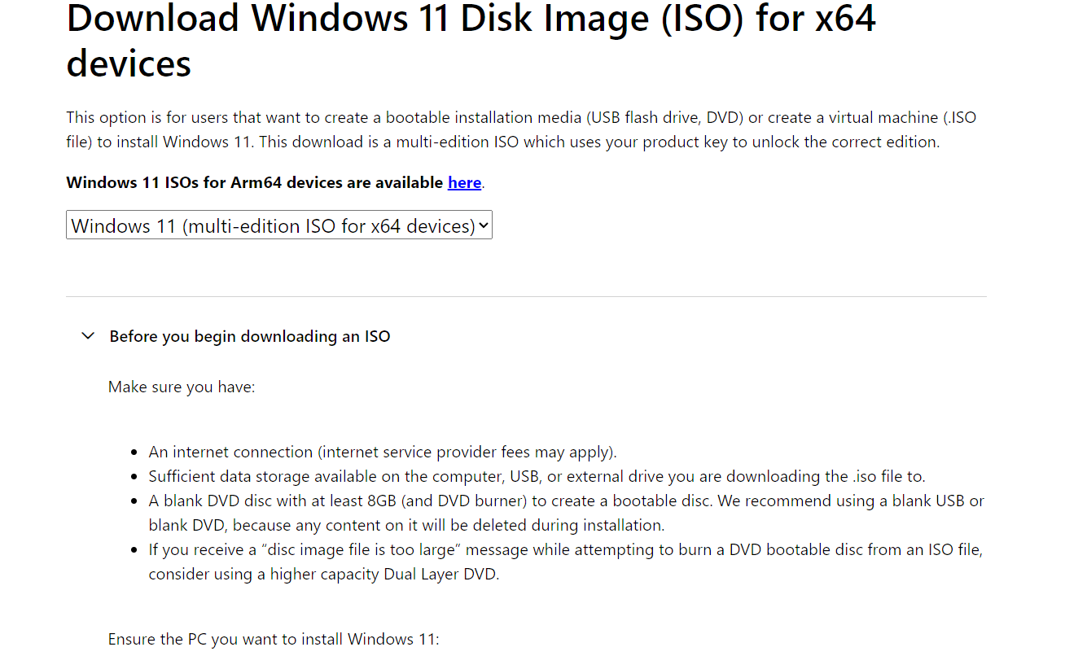
Step 2.2: Next, I opened VMware Workstation and selected the option to create a new virtual machine.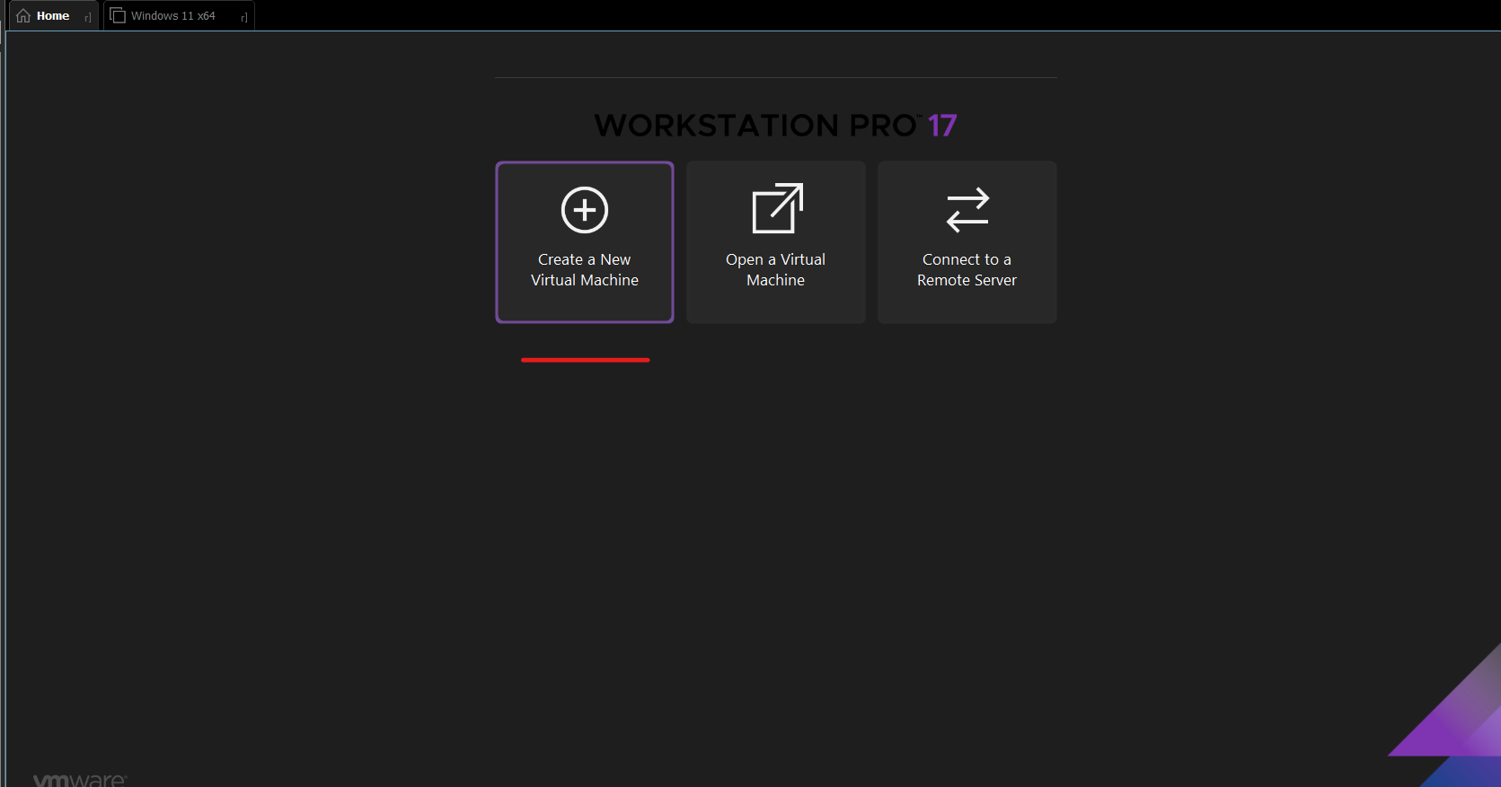
Step 2.3: It directed me to the Virtual Machine Wizard, where I selected the recommended Typical option, as shown in the screenshot.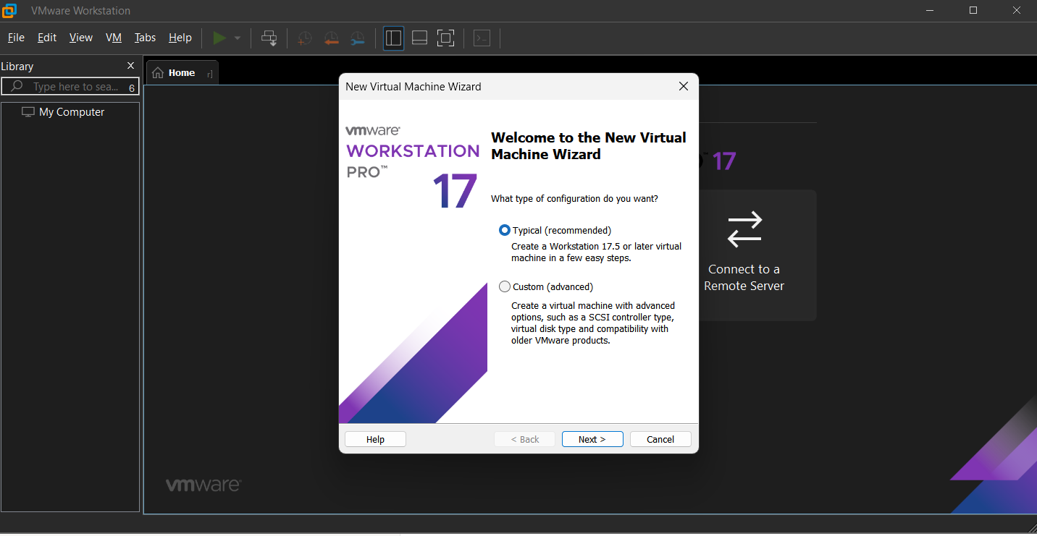

Step 2.4: Next, I selected the Windows 11 ISO image from my local drive to serve as the installation source, and then proceeded by clicking Next.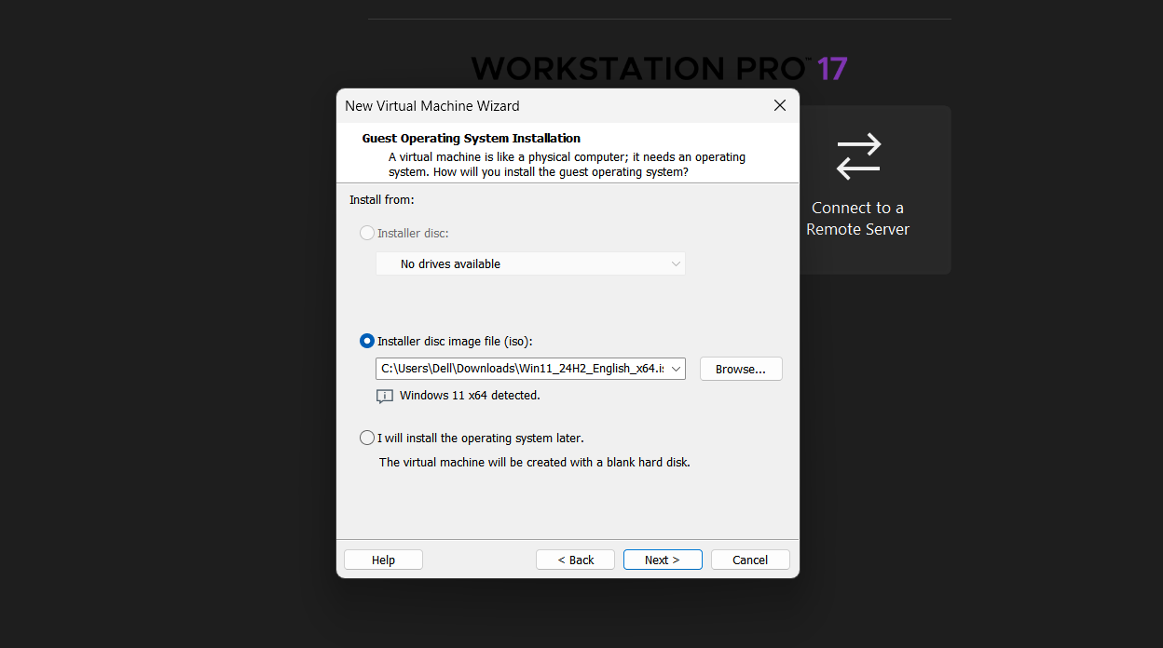

Step 2.5: In the next step, I was prompted to select the disk size for the virtual machine. Although the recommended size was 64 GB, I allocated 80 GB to allow for additional storage capacity. I also chose to store the virtual disk as a single file for improved performance and easier management, since I do not plan to move this VM to another computer.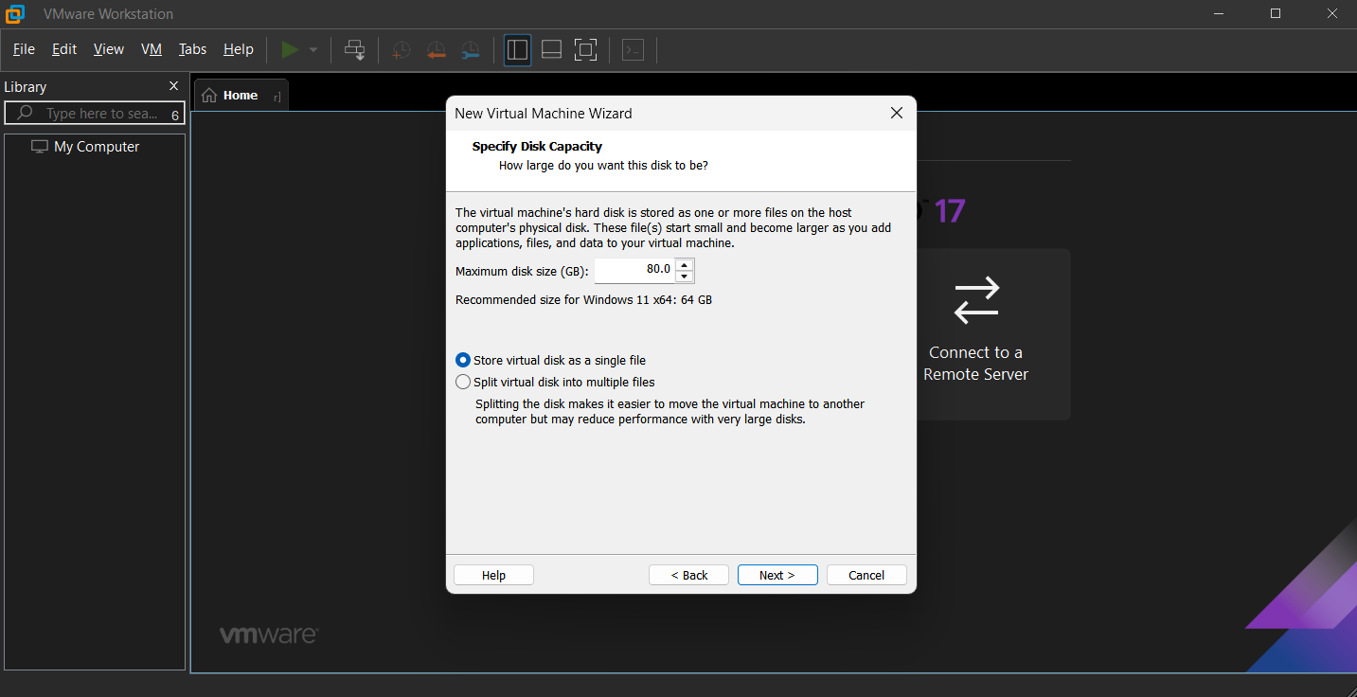
Step 2.6: Next, I was prompted with the encryption window, where I had to set a password to enable encryption. The wizard provided the option to encrypt either all files or only the files necessary to support TPM (Trusted Platform Module), which is required for Windows 11.
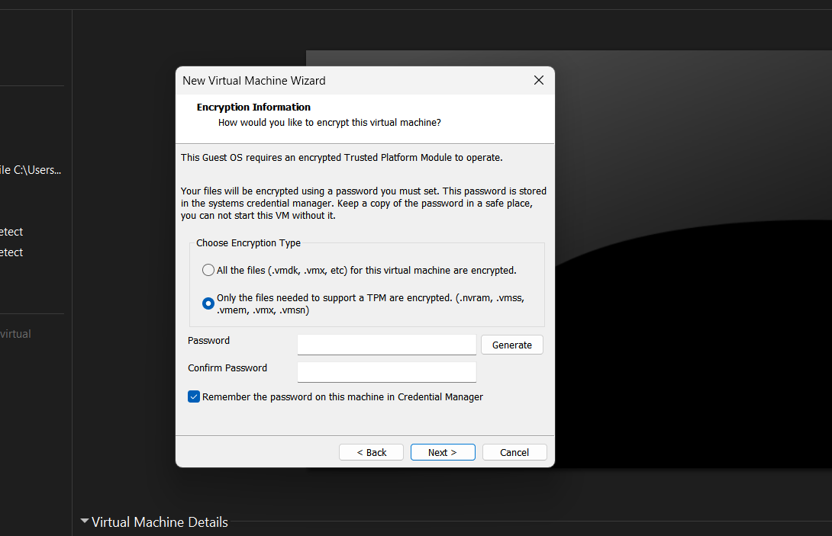
Step 2.7: In the final window of the Virtual Machine Setup Wizard, you are given the option to either customize the hardware settings (such as memory, processors, and network configuration) or simply click Finish to proceed with the default configuration.
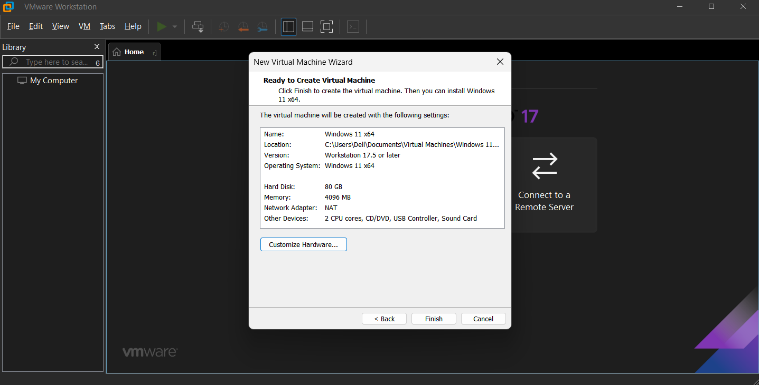
Step 2.8 (Optional): When selecting Customize Hardware, a window opens where you can adjust various hardware settings for the virtual machine, such as memory, processors, and display. In my case, I reviewed the Network Adapter settings and found that the default option was set to NAT, which was exactly what I needed.
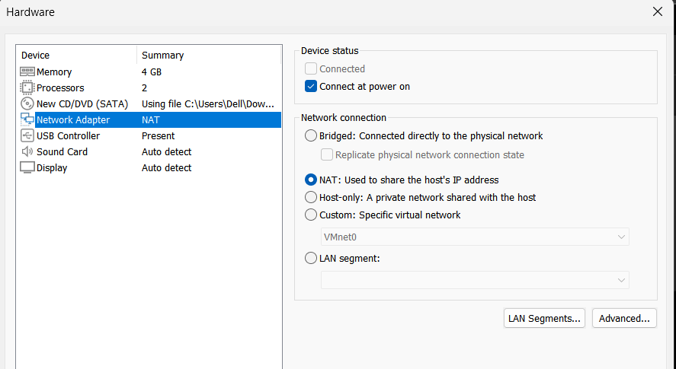

Step 2.9: After clicking Finish, the virtual machine starts automatically and begins booting the Windows setup from the CD/DVD (SATA), which is linked to the ISO image selected in step 2.4. Alternatively, this process could also be performed using a physical bootable device, such as a USB drive.
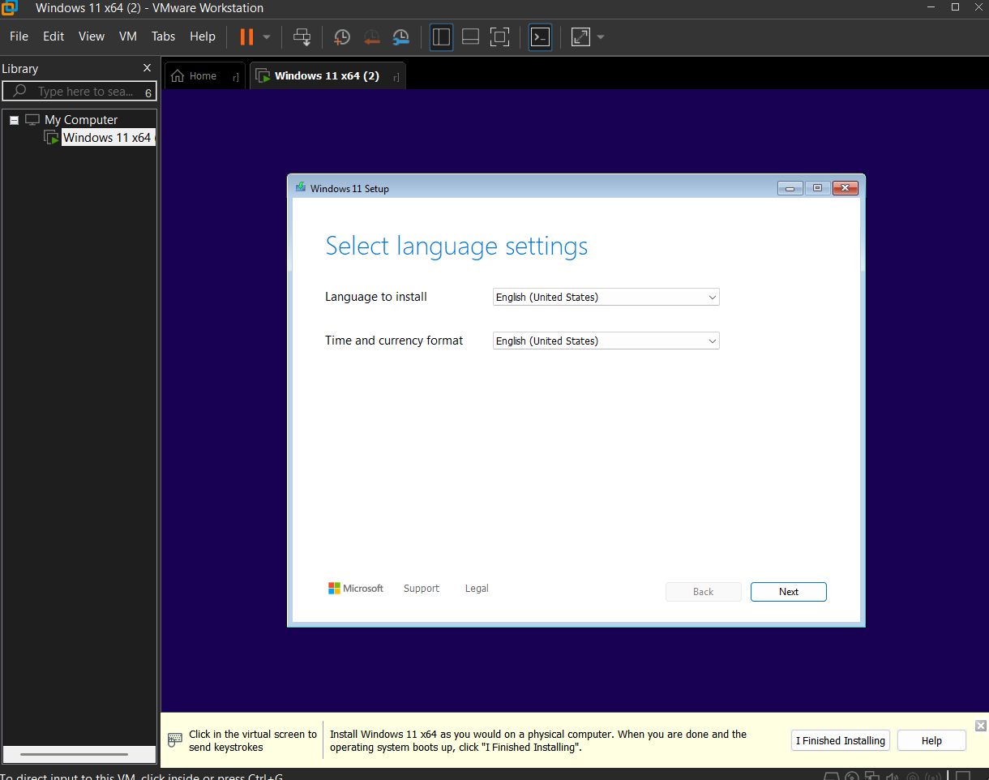
Step 2.10: In the next step, I proceeded through the standard Windows setup process, following the on-screen instructions as usual.
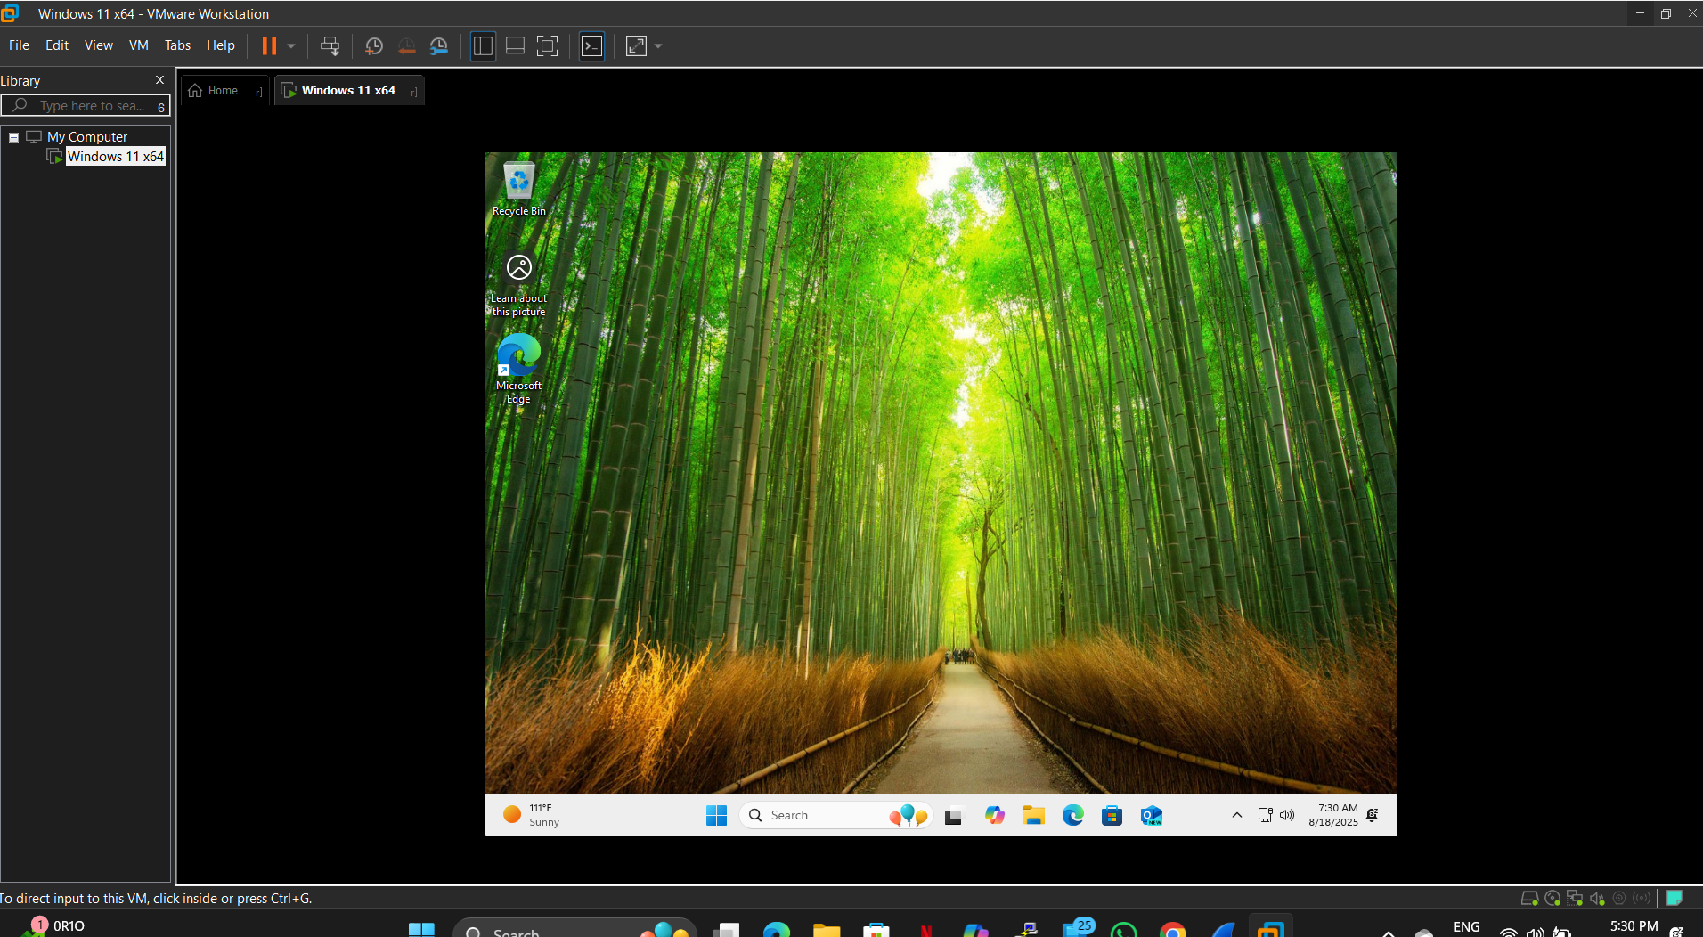
Step 2.11: To modify the virtual machine settings again, right-click on the VM and select Settings.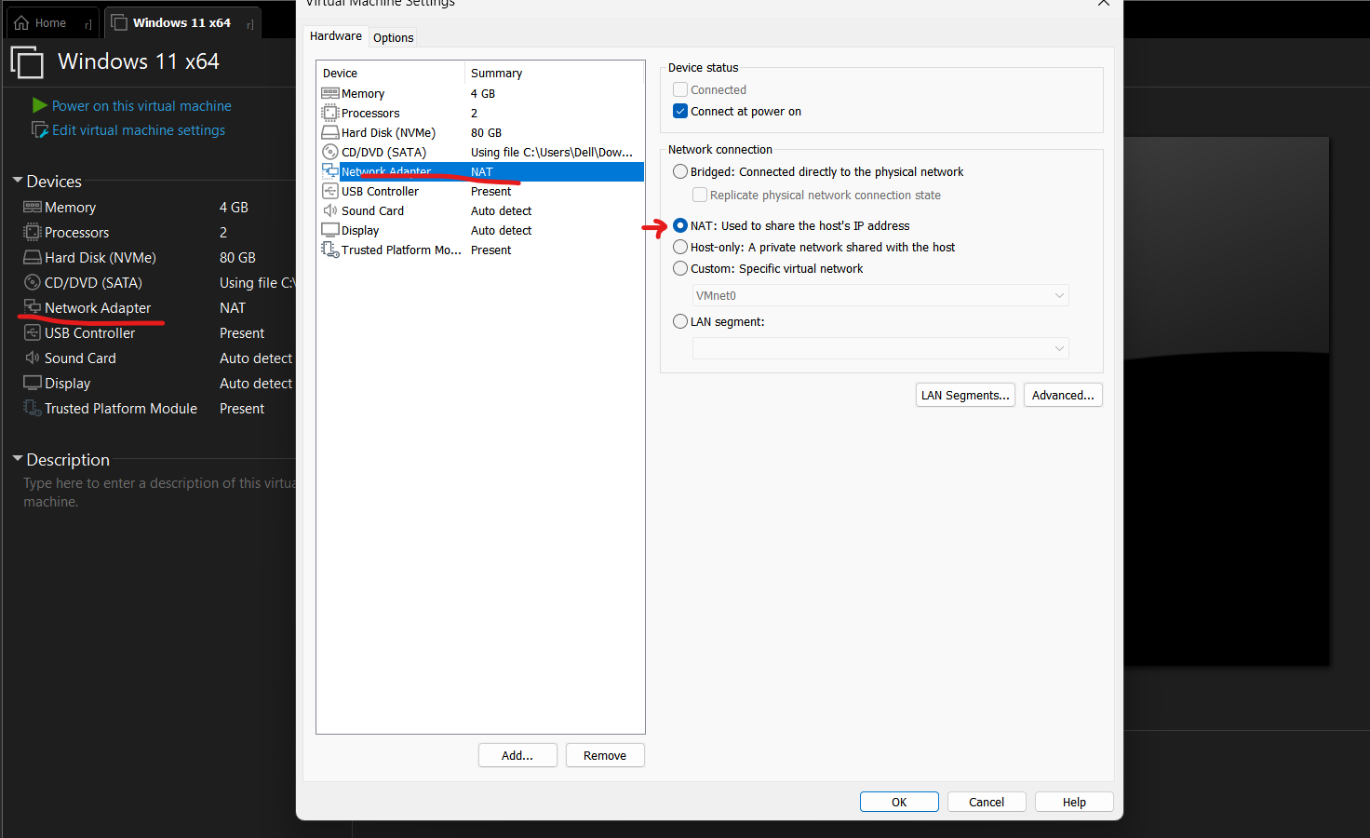

Step 2.12: At this stage, I confirmed that the virtual machine had internet access through the NAT network configuration.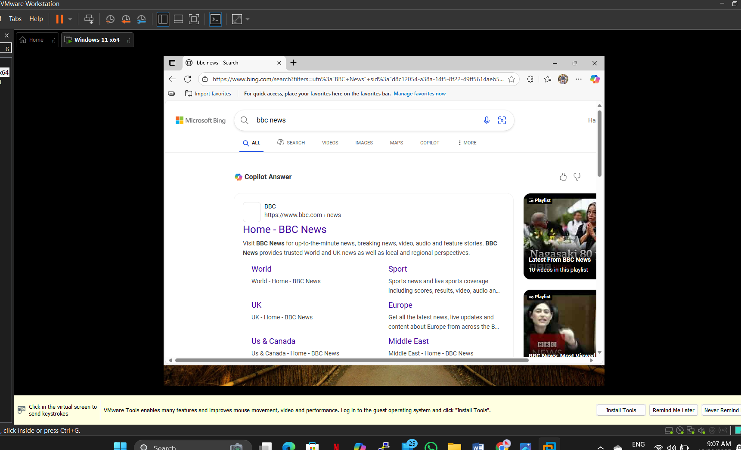

Part 3: Creating VM #2 – Debian Linux (Ubuntu)

Step 1: Downloading Ubuntu and Running It on Virtual Machine #2
Step 1.1: I chose Ubuntu for this setup.
You can choose to download either Ubuntu or Kali Linux based on your preference:
- For Ubuntu, visit: ubuntu.com/download
- For Kali Linux, visit: debian.org/distrib
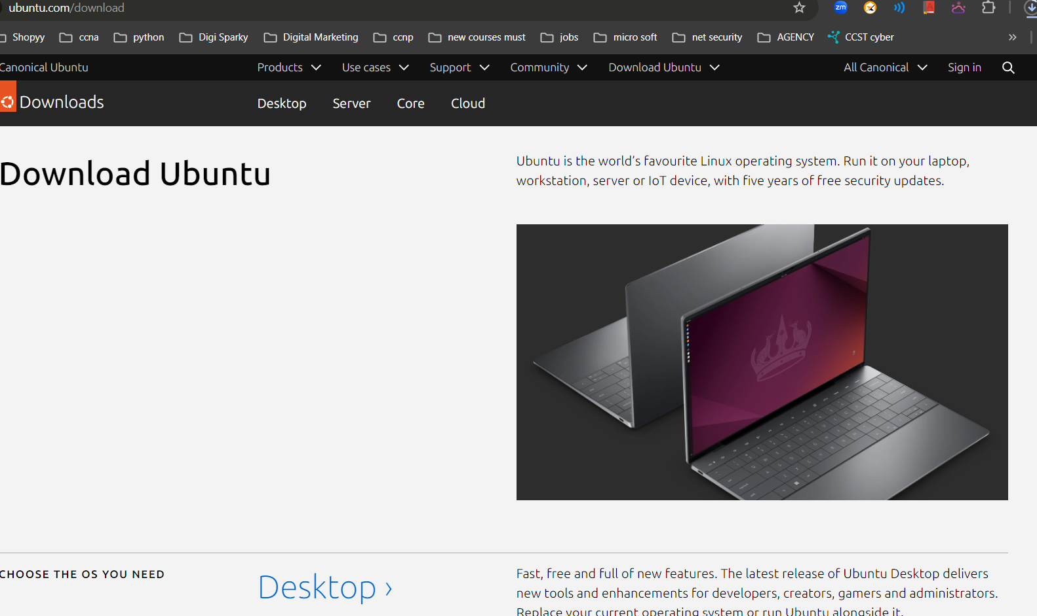

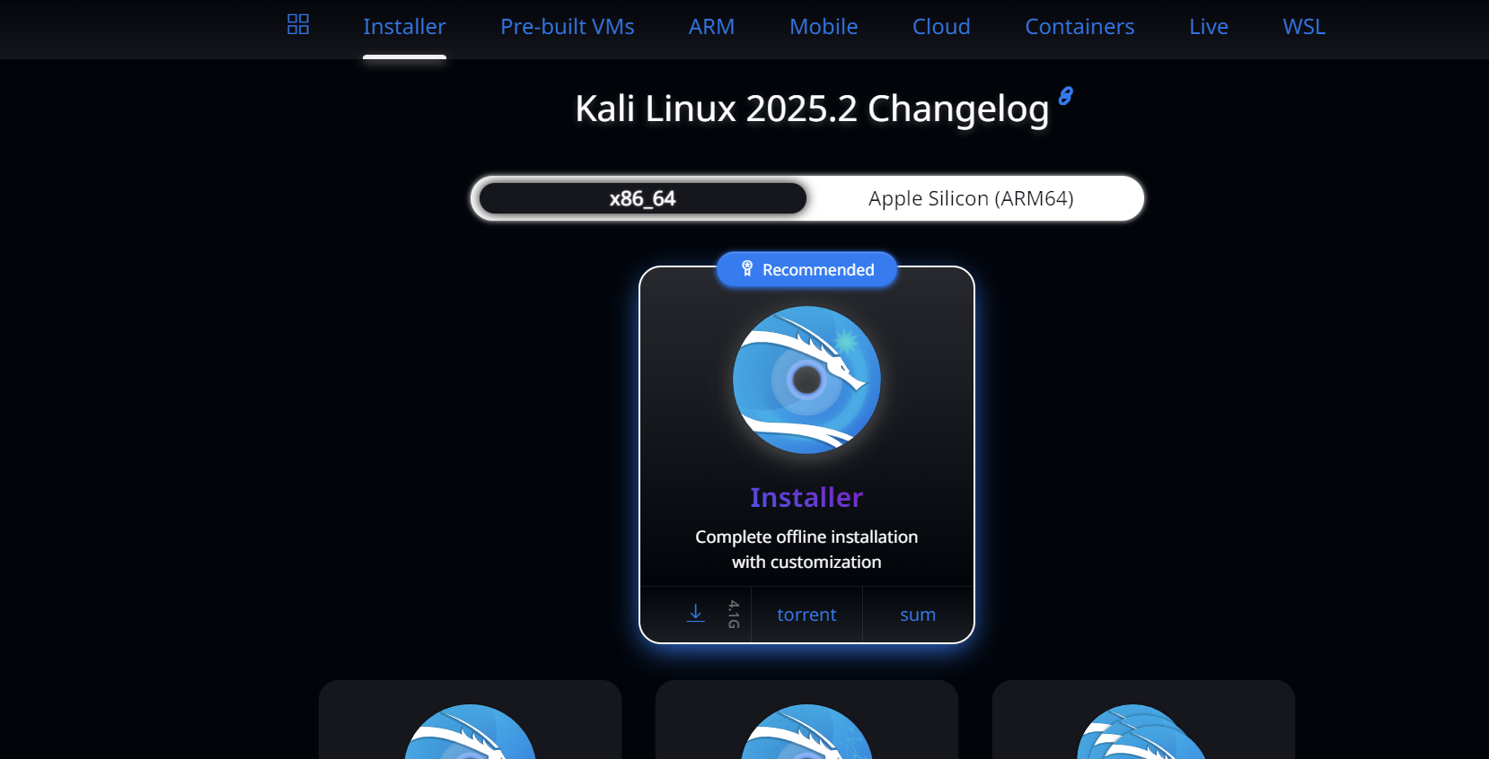

Step 1.2: I followed essentially the same process for setting up the Ubuntu virtual machine as I did for the Windows VM.
Step 1.3: The only change I made for the Ubuntu VM was to configure the Network Adapter in the VM settings and select the Bridged option. Initially, the network connection did not work, so I performed the following checks on the host system to ensure proper connectivity:
Verify VMware Network Services on the Host:
VMware creates virtual network adapters (VMnet0, VMnet1, VMnet8). If these adapters are disabled or corrupted, the VM will not have internet access.
On a Windows 11 host:
- Press Win + R, type ncpa.cpl, and press Enter.
  - Ensure that VMware Network Adapter VMnet1 (Host-only) and VMnet8 (NAT) are enabled (not greyed out).
- Ensure VMware network services are running:
  - Press Win + R, type services.msc, and press Enter.
  - Locate VMware DHCP Service and VMware NAT Service.
  - Confirm that both services are set to Running and Automatic. If not, right-click and select Start.
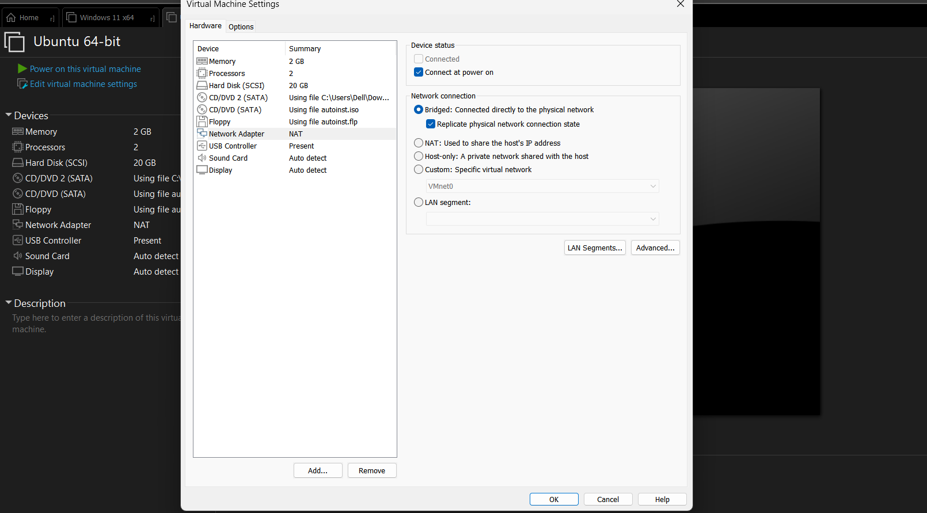
In my case, I selected the Custom network option and then chose the virtual network available on my local machine, either VMnet1 or VMnet8, for the VM connection.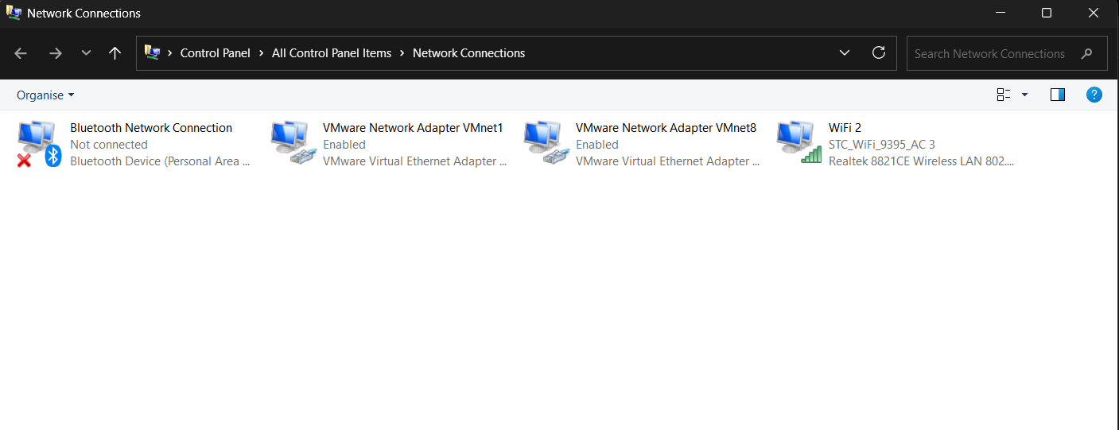
Finally, I was able to access the network inside the virtual machine using the Bridged network configuration.
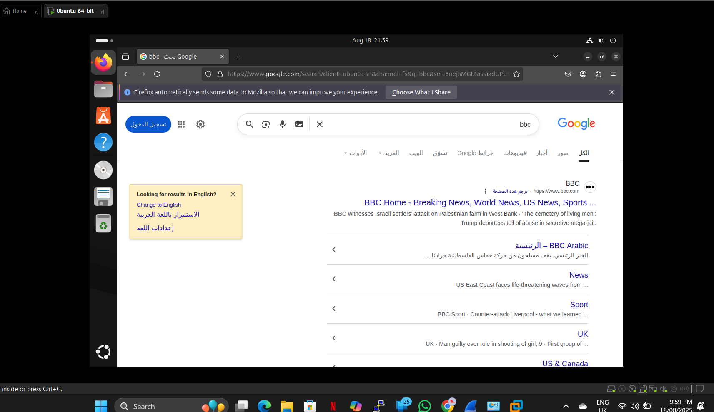
Conclusion:
By completing this project, I successfully established a multi-OS virtual lab, consisting of a Windows VM on a secure NAT network and a Debian Linux VM on a Bridged network. This environment enables safe experimentation with SOC tools, malware analysis, and cross-platform troubleshooting. The project highlights technical proficiency in virtualization and demonstrates the ability to design practical, enterprise-like training environments that support hands-on learning and testing.

